**E-Voting System Project By Moksha Dhall**

1.Home Page

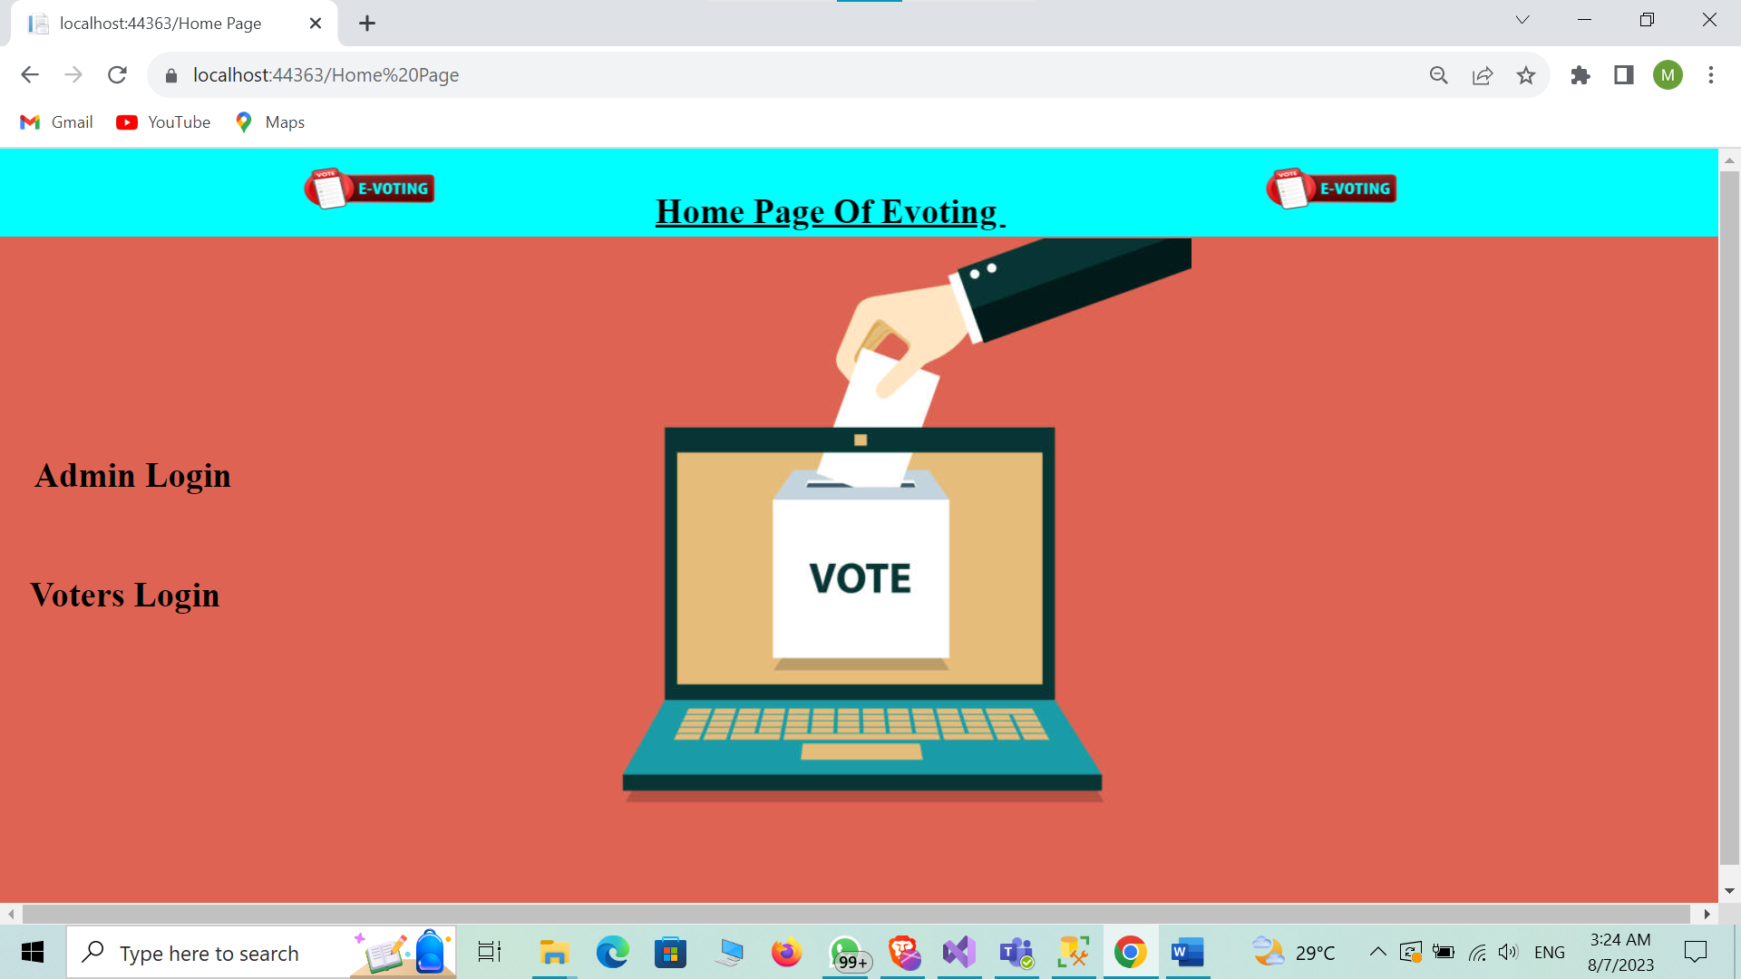

2.Admin Login Page

3.Admin Panel Page

4.Manage Elections /Elections Page

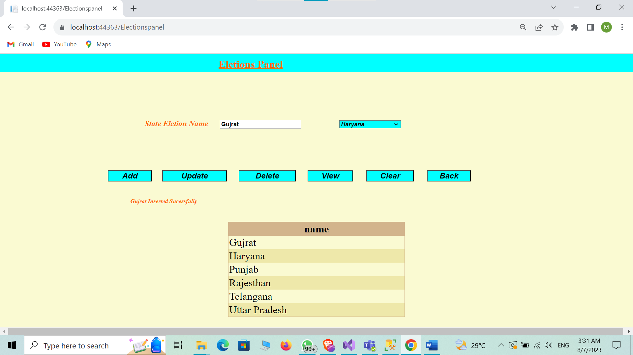

5.Manage Candidate Page

6.Manage Voters Page

7.View Voters Page

8.Voters Login Page

9.Voters Panel Page

10.Change Password Page

11.Voters In Election Page

